
Luxembourg, 30.03.2026

One-day excursion to Cologne, Germany:
Tuesday 24 March 2026
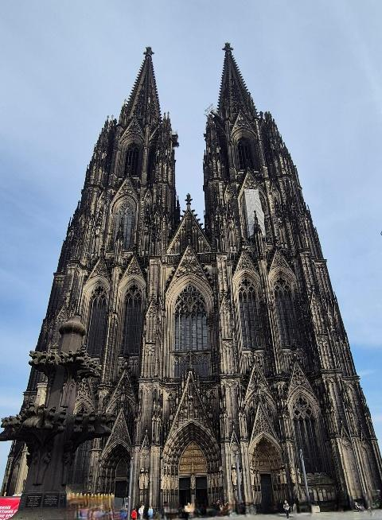
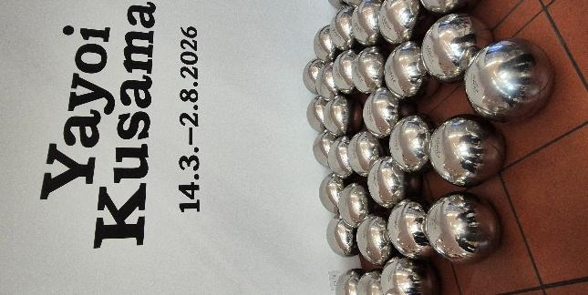
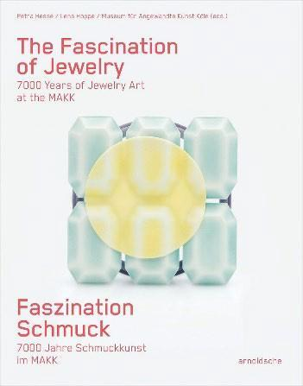
Despite the early start, 28 intrepid art history enthusiasts set out from the Glacis parking lot at 7.30 am towards Germany to explore 7000 years of jewellery art and the work of the celebrated Japanese artist Yayoi Kusama in a major retrospective spanning her 70-year career.

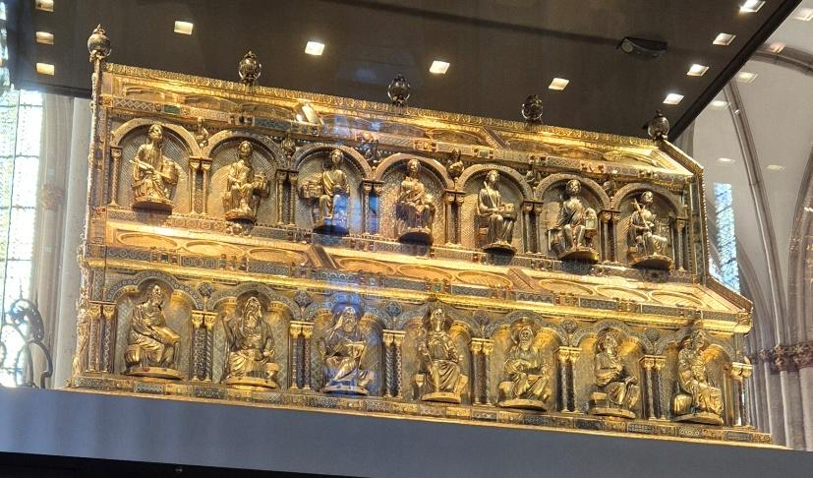
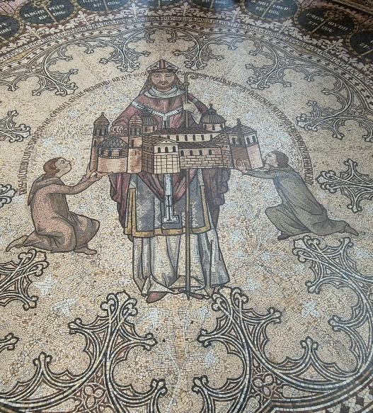
Having arrived at the Museum of Applied Arts (MAKK) in good time and delighted by the prospect of a warm and dry spring day, the travellers split into two groups for the planned staggered tours in French of the permanent exhibition “The Fascination of Jewellery: 7000 Years of Jewellery Art at the MAKK”. While one group focussed on the displays in the exhibition rooms, the other group took advantage of the free time to enjoy refreshments in a nearby traditional 1950s-style café on the central Wallrafplatz square and to visit Cologne’s Gothic Cathedral, the world’s tallest twin-spired church and host to the gilded Shrine of the Three Kings crafted in 1190 and detailed mosaic floors created from Villeroy and Boch ceramic tesserae. (Un)fortunately there was not sufficient time to climb the 533 steps to the viewing platform. Other participants chose to visit the special temporary exhibition at the MAKK on “Jewellery by famous Female Artists”, featuring pieces designed by Yoko Ono and Niki de Saint Phalle among others.

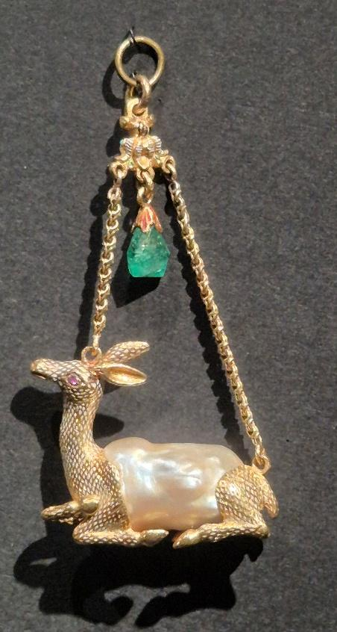
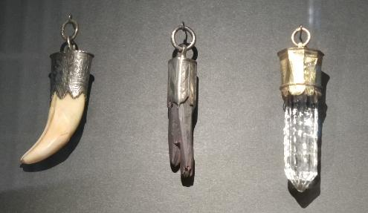
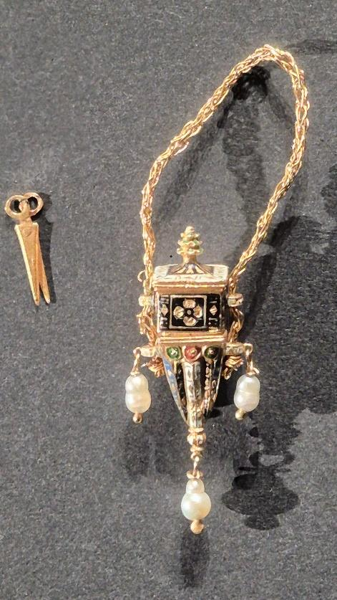
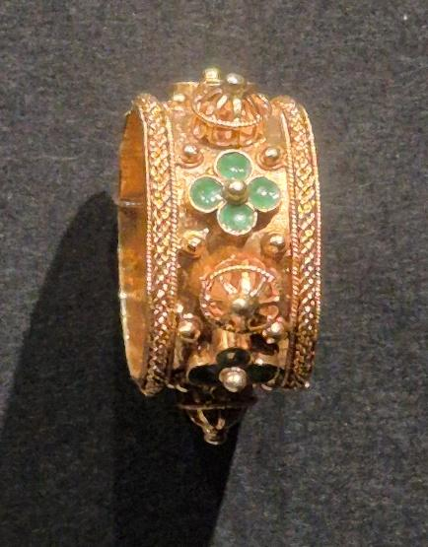
Our knowledgeable local guide gave a 1-hour tour of the permanent exhibition, walking us through both a chronological journey and a thematic exploration of jewellery across cultures and time. Following a 7000-year timeline of jewellery, featuring around 370 objects selected from a much larger collection, we moved from ancient Middle-Eastern gems (5th century BC) to contemporary experimental pieces, with explanations on how jewellery evolved in form, technique and meaning. In parallel, exhibits were organised to show that jewellery is not just decorative, but also reflects human values and society. Several cross-period themes were highlighted including:
- symbolism and belief: jewellery as protection, religious expression, or status symbol;
- utility: jewellery serving practical purposes;
- memory and identity: objects used to commemorate people, relationships, or events;
- luxury and power: jewellery as a marker of wealth and authority;
- gender and social roles: how jewellery expresses identity and societal expectations;
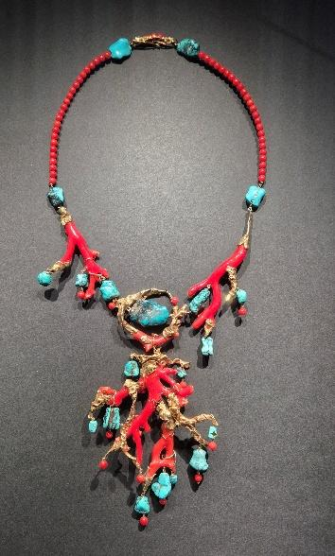
- nature and inspiration: designs influenced by plants, animals and other aspects of the natural world.
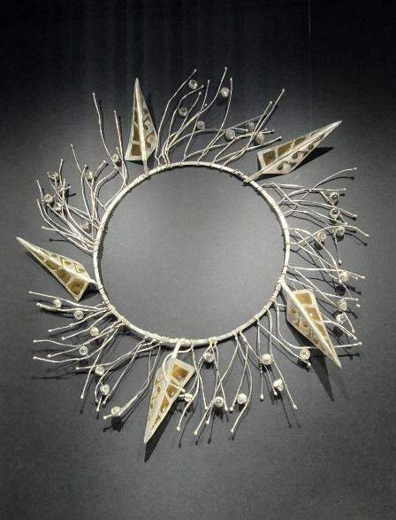
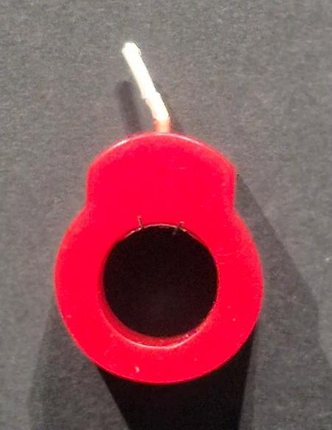

Early in the tour, the guide switched to English at the request of the participants as she clearly felt more comfortable using this language, and she responded expertly to numerous questions from the keen art aficionados.

At lunchtime, both groups checked out the nearby bakeries, cafés, and Eau de Cologne and chocolate shops and also took the opportunity to visit one of Cologne’s 12 Romanesque churches, St Andrew’s, where we admired the vibrant stained-glass windows by German artist Markus Lüpertz. In the crypt of the church, we came across a Roman sarcophagus from the 3rd Century, which holds the remains of the 13th Century theologian and natural philosopher Saint Albertus Magnus.

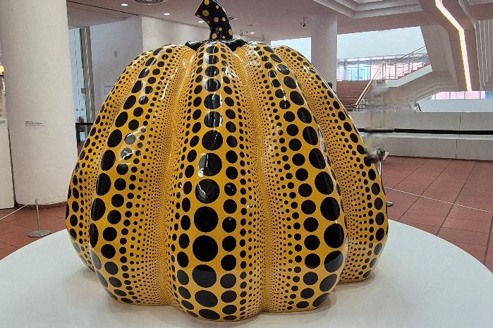
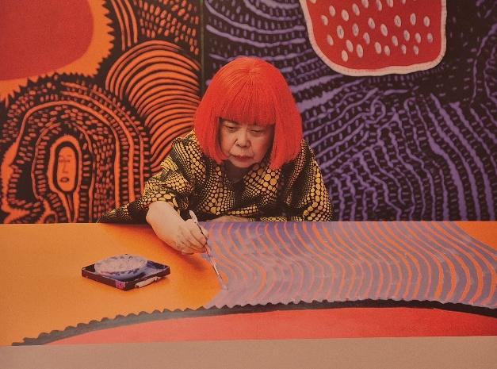
Following the lunch break, we made our way to the nearby Ludwig Museum located next to the main train station to meet again with our guide for a tour of the temporary “Yayoi Kusama” exhibition. The guide provided a short introduction to the artist, pointing out that she had recently celebrated her 97th birthday and that she had been living for many years in a psychiatric institution in Japan where she still practised her art. We learned that experiences from Kusama’s childhood, including hallucinations in which she perceived dots, flowers, and other repeating patterns that engulfed her entire body, run like a thread through the artist’s oeuvre. Kusama’s practice revolves around nature and its state of constant transformation, of becoming and decay, and the boundlessness of the universe, in which everything that exists eventually perishes. The polka dot pattern used by the artist to cover objects and people is as much an expression of this worldview as her Infinity Mirror Rooms.

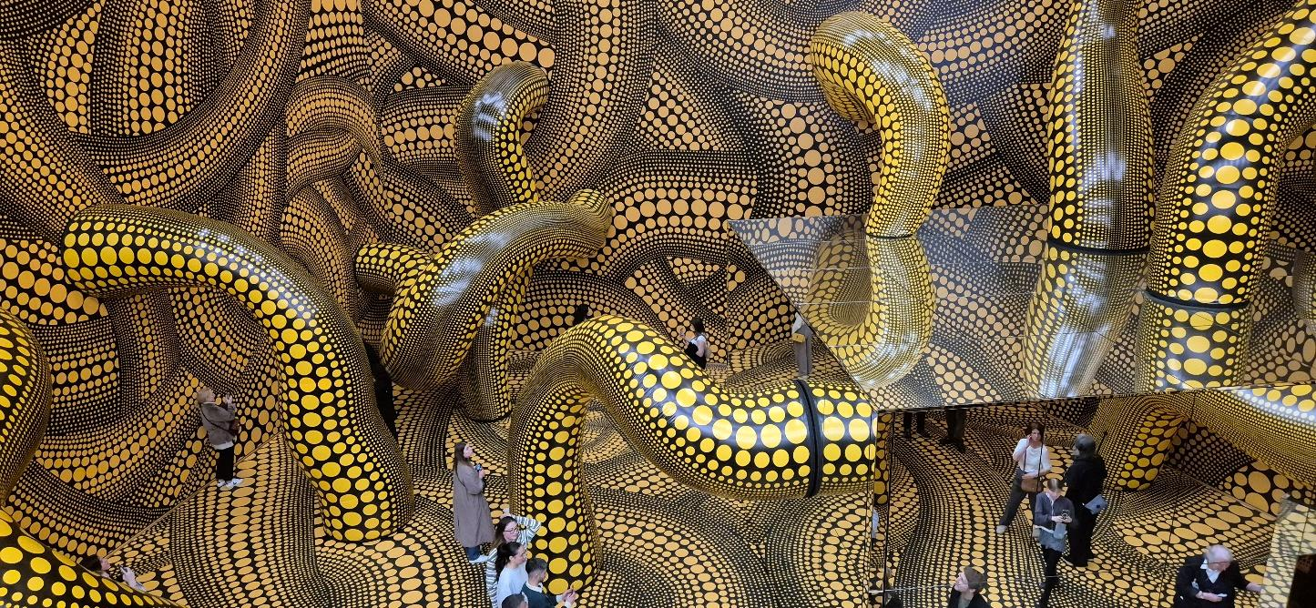

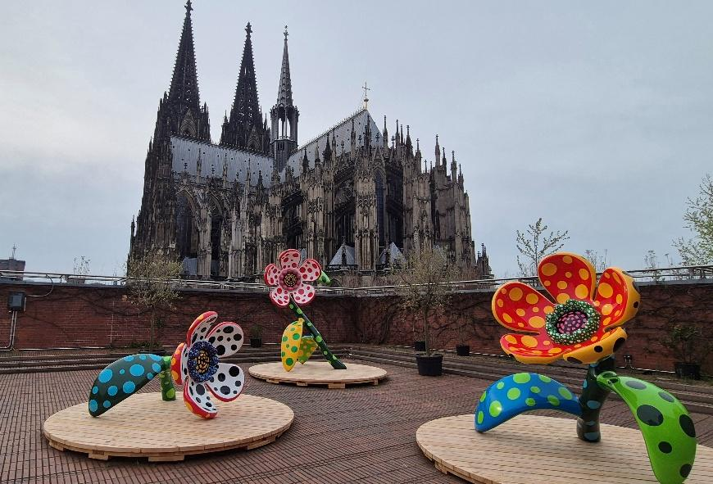
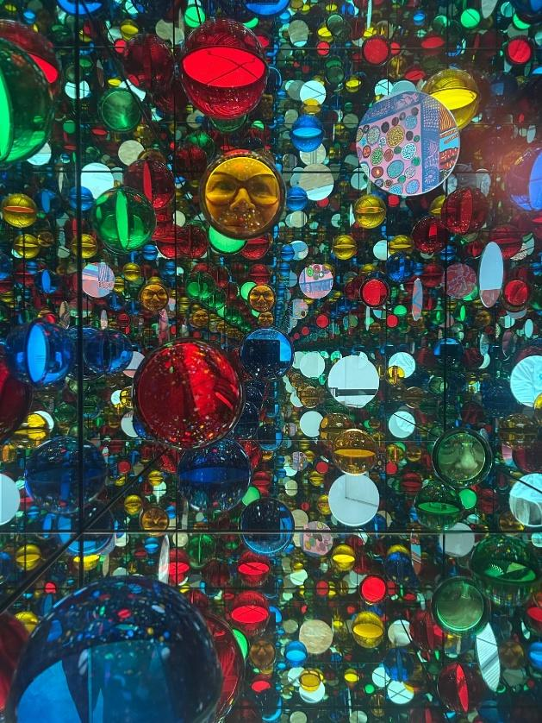
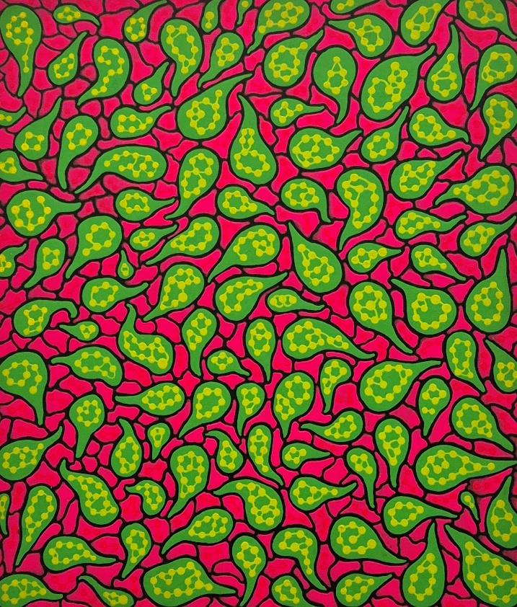
We proceeded to take in the highlights of this vast retrospective from her first drawings as a child, dating back to 1934, via striking sculptures, paintings and immersive artworks featuring her signature polka dots, pumpkins, tentacles and mirrors, to a newly commissioned Infinity Mirrored Room, a jungle-like space made up of gigantic yellow tendril-like shapes with streams of black dots, As we moved from one room to the next, the exhibition unfurled like one of Kusama’s tentacles with explosions of shapes and colours, filling even the largest hall and spreading out onto the roof terrace, where several painted bronze flowers lent a whimsical touch to the imposing cathedral. The interactive and immersive installations also added an element of fun that set this exhibition apart.

After a brief visit to the museum shop to discover that the prices of the exhibition merchandise clearly reflected the massive commercialisation of Kusama’s work and her collaboration with luxury brands (99€ for a T-shirt!), the two groups rejoined the bus driver in front of the cathedral at 5.45 pm and we headed back to Luxembourg, arriving at around 8.30 pm. The participants agreed it had been a fascinating trip and the spectacular Kusama exhibition was definitely not to be missed. The 28 weary travellers then dispersed happily with many new impressions and ideas to mull over.

